Using Single-Row Functions to Customize The Output
1. Write a query to display the current date. Label the column Date.
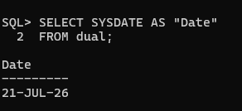

2. Display the employee number, last name, salary, and salary increased by 15.5% (expressed as a whole number). Label the column New Salary.
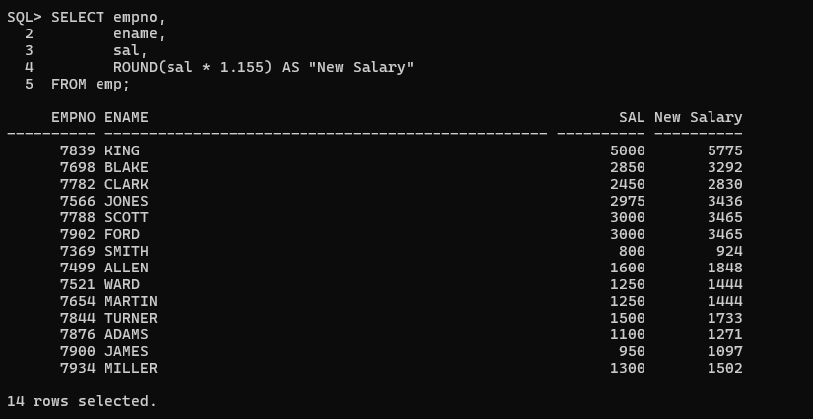
3. Modify the previous query to add a column that subtracts the old salary from the new salary. Label the column Increase.
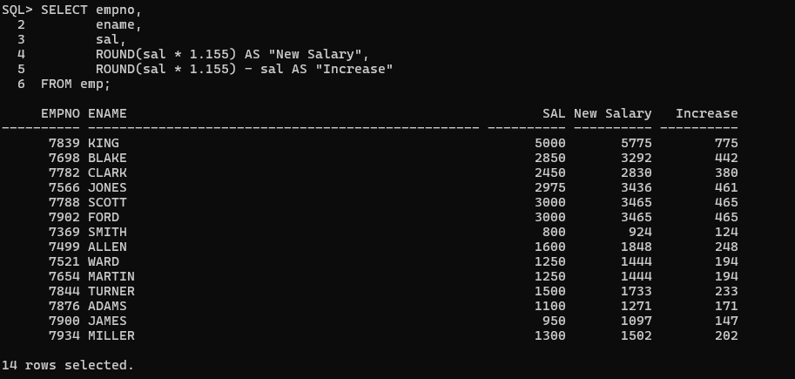
4. Display the ename (first letter uppercase and remaining letters lowercase) and the length of the ename for all employees whose name starts with J, A, or M. Give appropriate labels. Sort the results by ename.
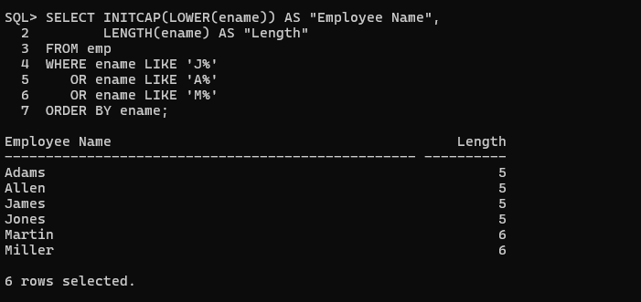
5. Rewrite the previous query so that the user is prompted to enter the starting letter of the last name.
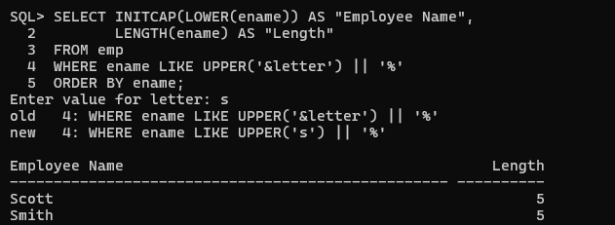

6. Display the ename and the number of months between today and the hire date. Label the column MONTHS_WORKED. Round to the nearest whole number. Order by months worked.
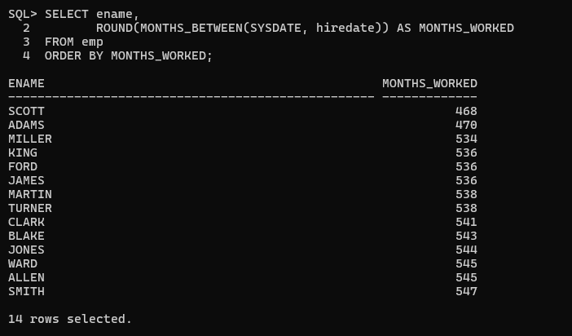

7. Display: "<employee> earns <salary> monthly but wants <3*salary>". Label the column Dream Salaries.
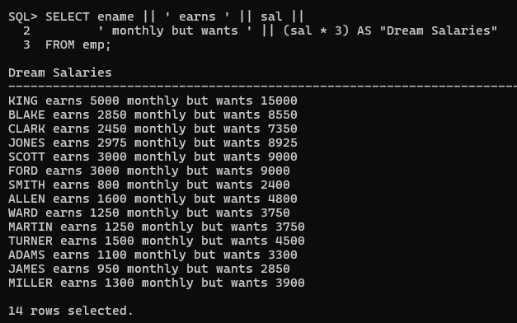

8. Display the last name and salary. Format the salary to 15 characters, left-padded with the '$' symbol. Label the column SALARY.
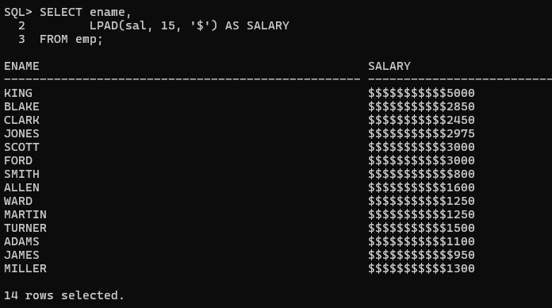

9. Display each employee's last name, hire date, and salary review date, which is the first Monday after six months of service. Label the column REVIEW. Format the dates like "Monday, the Thirty-First of July, 2000".
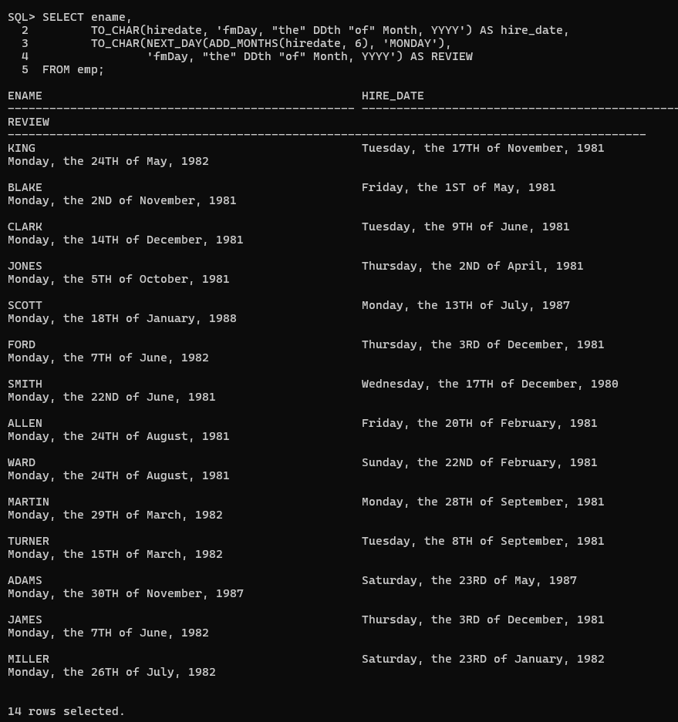10. Display the last name, hire date, and day of the week on which the employee started. Label the column DAY. Order the results by the day of the week, starting with Monday.
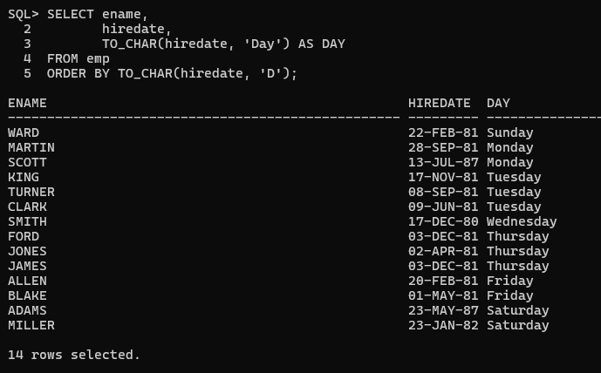

11. Display the employees' last names and commission amounts. If an employee does not earn commission, show "No Commission." Label the column COMM.
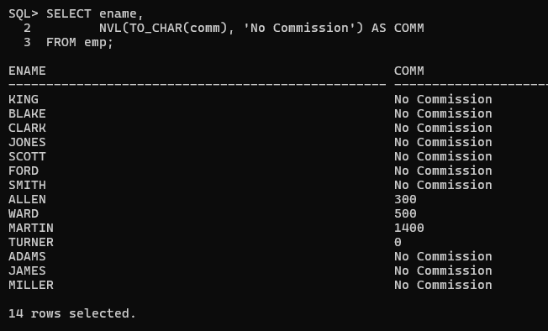

12. Display the first eight characters of the employees' last names and indicate their salaries with asterisks. Each asterisk represents $1000. Sort by salary in descending order. Label the column EMPLOYEES_AND_THEIR_SALARIES.
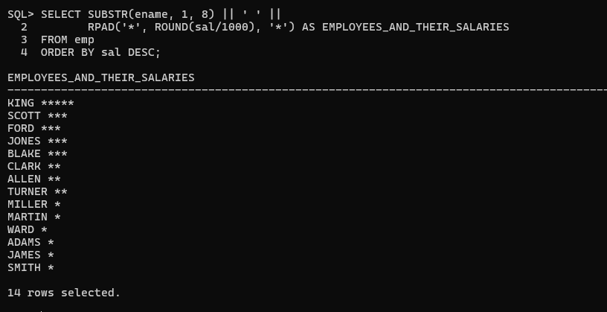
13. Using the DECODE function, display the grade of all employees based on the JOB column.
- PRESIDENT → A
- MANAGER → B
- SALESMAN → C
- CLERK → D
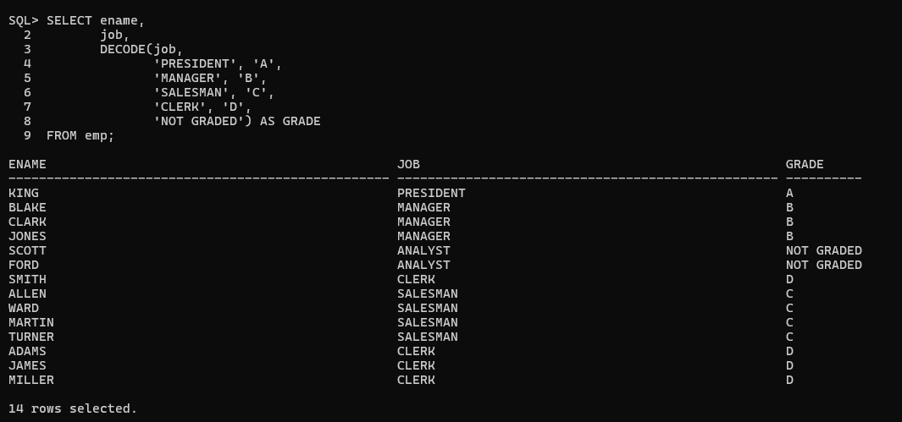

14. Rewrite the previous query using the CASE syntax.
